Angular
Sameerashaik1005@gmail.com
Student Course Portal

Description :
Student Course Portal is an Angular standalone application developed as part of Angular Hands-On exercises.
Features :
- Home Page
- Course List
- Course Details
- Student Profile
- Routing
- Route Guards
- Lazy Loading
- Template Driven Forms
- Reactive Forms
- Services and Dependency Injection
- HTTP Client (GET, POST, PUT, DELETE)
- JSON Server Integration
- NgRx State Management
- Unit Testing
Technologies Used:
- Angular
- TypeScript
- HTML
- CSS
- RxJS
- JSON Server
Installation:
Clone the repository:
git clone https://github.com/your-username/student-course-portal.git
Install dependencies:
npm install
Run the project:
ng serve
Open:
http://localhost:4200
Run JSON Server:
json-server --watch db.json --port 3000
Author:
Sameera Shaik

Output:

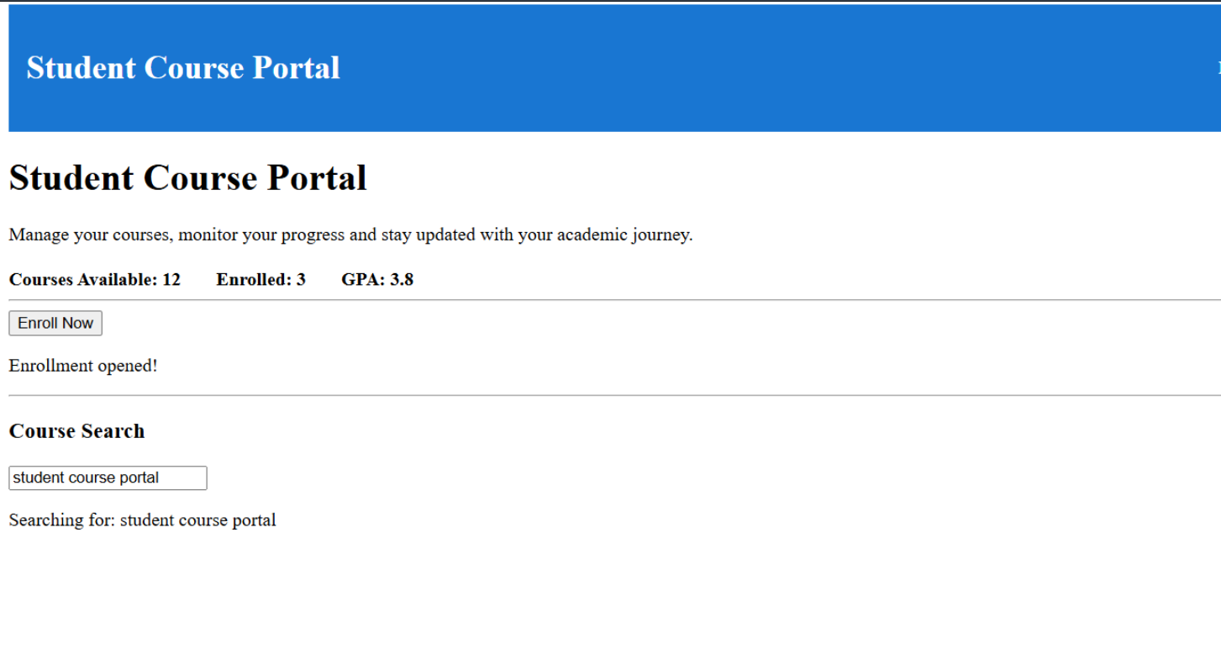

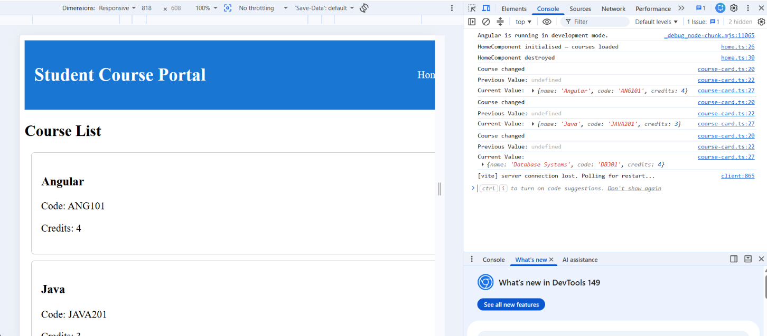
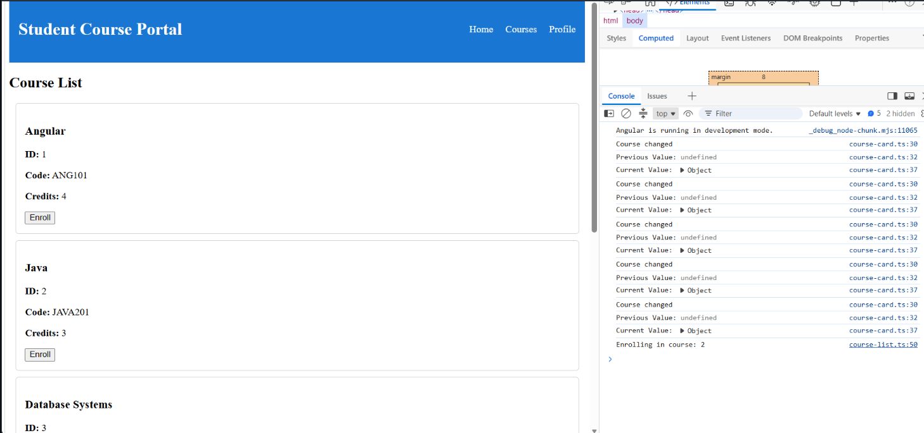

Home.ts:

import { Component } from '@angular/core';
import { CommonModule } from '@angular/common';
import { CourseService } from '../../services/course.service';
@Component({
selector: 'app-home',
standalone: true,
imports: [CommonModule],
templateUrl: './home.html',
styleUrl: './home.css'
})
export class HomeComponent {
courses: any[] = [];
constructor(private service: CourseService) {
this.loadCourses();
}
loadCourses() {
this.service.getCourses().subscribe(data => {
this.courses = data;
});
}
addCourse() {
const course = {
name: "React",
instructor: "James",
credits: 4
};
this.service.addCourse(course).subscribe(() => {
this.loadCourses();
});
}
updateCourse() {
const updated = {
id: 1,
name: "Angular Advanced",
instructor: "John",
credits: 5
};
this.service.updateCourse(1, updated).subscribe(() => {
this.loadCourses();
});
}
deleteCourse() {
this.service.deleteCourse(3).subscribe(() => {
this.loadCourses();
});
}
}

Home.html:

<h1>HTTP Client Demo</h1>
<button (click)="addCourse()">
Add
</button>
<button (click)="updateCourse()">
Update
</button>
<button (click)="deleteCourse()">
Delete
</button>
<hr>
<div *ngFor="let course of courses">
<h3>{{course.name}}</h3>
<p>{{course.instructor}}</p>
<p>{{course.credits}}</p>
<hr>
</div>

App.ts:

import { Component, OnInit } from '@angular/core';
import { RouterOutlet } from '@angular/router';
import { HeaderComponent } from './header/header';
import { Store } from '@ngrx/store';
import { Observable } from 'rxjs';
import { loadUsers } from './store/actions/user.actions';
import { selectUsers } from './store/selectors/user.selector';
@Component({
selector: 'app-root',
standalone: true,
imports: [
RouterOutlet,
HeaderComponent
],
templateUrl: './app.html',
styleUrl: './app.css'
})
export class App implements OnInit {
users$: Observable<any[]>;
constructor(private store: Store) {
this.users$ = this.store.select(selectUsers);
}
ngOnInit() {
this.store.dispatch(loadUsers());
}
}
App.html:

<app-header></app-header>
<router-outlet></router-outlet>
<h2>User List</h2>
<div *ngFor="let user of users$ | async">
<p>
{{user.id}} - {{user.name}}
</p>
</div>

